Warrior Corps Youth Marching Band Camp!
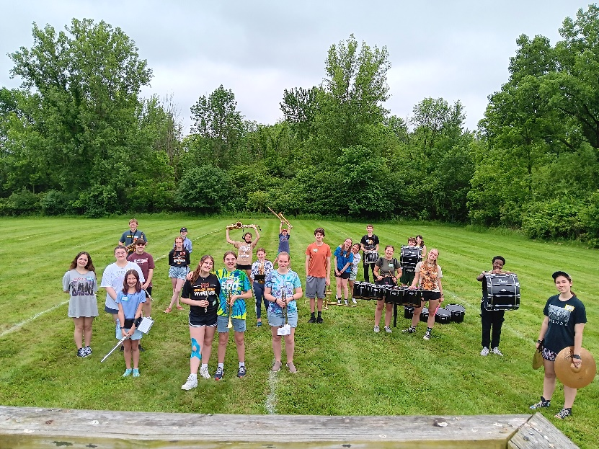

- Who: This camp is open to anyone entering grades 6 – 8 who has at least one year of experience playing their instrument!
- What: Participants learn some basic marching band fundamentals and will learn a song and drill routine on the field! Participants will also get to spend time with our current high school band members, play some fun games, and enjoy some treats!
- Where: The camp will take place at Walsh Jesuit High School. Time will be spent both indoors in the band room and outside on our practice field!
- When: Monday and Tuesday, June 16th and 17th, 12:30-3:00PM each day.
- Why: You will get to experience what it is like to be in high school marching band. You will learn some new skills! You will get to make new friends and learn about our music community here at Walsh Jesuit!
The cost to participate will be $30.00. There will be no charge for students who are also participating in the Ignite Summer Enrichment Program. Please email Nicholas Ratay (band director) at ratayn@walshjesuit.org with questions. You can register with the following link: https://walshjesuit.myschoolapp.com/page/event-detail?siteId=1030&ssl=1&register=52232

